Experiment Name: Circle in Open GL

Introduction: In this project, I make a picture that uses Open GL to draw the fundamental shapes of a Circle. Through Open GL, I will learn how to draw shapes.

Code:

#include <stdio.h>

#include <GL/gl.h>

#include <GL/glut.h>

float x=0,y,x2,y2,m,i,j,p;

int dx=0,dy=0,r;

void display(void)

{

/* clear all pixels */

glClear (GL_COLOR_BUFFER_BIT);

/* draw white polygon (rectangle) with corners at

* (0.25, 0.25, 0.0) and (0.75, 0.75, 0.0)

*/

glEnd();

glColor3f (0.0, 1.0, 0.0);

glBegin(GL_POINTS);

p=1-r;

while((x<=y)){

if(p<0){

x=x+1;

y=y;

printf("%0.2f %0.2f\n",x,y);

p=p+(2*x)+1;

}

else{

x=x+1;

y=y-1;

printf("%0.2f %0.2f\n",x,y);

p=p+(2*x)+1-(2*y);

}

glVertex3f (((x/100)), ((y/100)), 0.0);

glVertex3f (((y/100)), ((x/100)), 0.0);

glVertex3f ((-(x/100)), (-(y/100)), 0.0);

glVertex3f ((-(x/100)), ((y/100)), 0.0);

glVertex3f (((x/100)), (-(y/100)), 0.0);

glVertex3f (((y/100)), (-(x/100)), 0.0);

glVertex3f ((-(y/100)), (-(x/100)), 0.0);

glVertex3f ((-(y/100)), ((x/100)), 0.0);

}

glEnd();

/* don't wait!

* start processing buffered OpenGL routines

*/

glFlush ();

}

void init (void)

{

/* select clearing (background) color */

glClearColor (0.0, 0.0, 0.0, 0.0);

/* initialize viewing values */

glMatrixMode(GL_PROJECTION);

glLoadIdentity();

glOrtho(-1.0, 1.0, -1.0, 1.0, -1.0, 1.0);

gluOrtho2D(-300, 300, 0, 600);

}

int main(int argc, char** argv)

{

printf("Enter radius: ");

scanf("%d",&r);

y=r;

glutInit(&argc, argv);

glutInitDisplayMode (GLUT_SINGLE | GLUT_RGB);

glutInitWindowSize (500, 500);

glutInitWindowPosition (100, 100);

glutCreateWindow ("hello");

init ();

glutDisplayFunc(display);

glutMainLoop();

return 0; /* ISO C requires main to return int. */

}

Output:

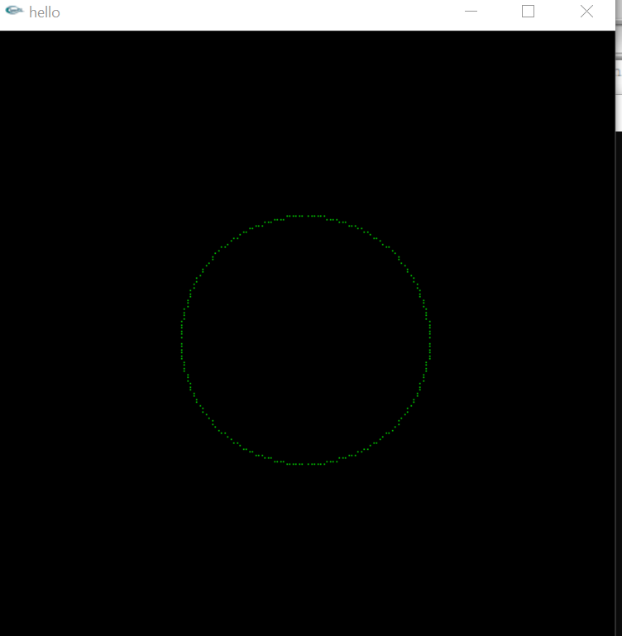

Conculation: This circle diagram using the function glutInit (&argc, argv).some function are glutInitWindowSize(500, 500). the starting position for the window using the function glutInitWindowPosition (100, 100).Initialize the window and set the title using the function glutCreateWindow(“hello”).Initialize the myInit() function and perform the following steps:Set the background color to orange using the function glClearColor(0.0, 1.0, 0.0). glOrtho(-1.0, 1.0, -1.0, 1.0, -1.0, 1.0);gluOrtho2D(-300, 300, 0, 600);Initialize the myDisplay() function .